Verilog Experiment - Part 3

Experiment 10

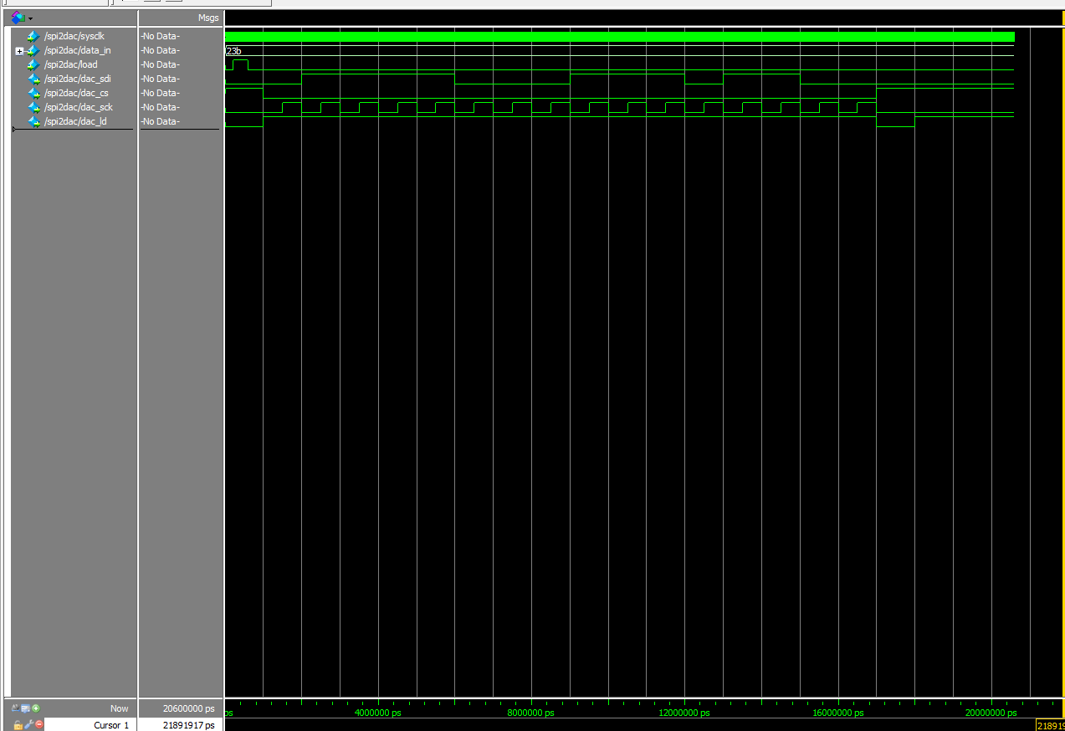In this experiment we used switches to load data to the spi2dac module, when all switches were off the output was 0V at SP9 and when all switches were on the output was 3.3V on SP9 which was expected and required.

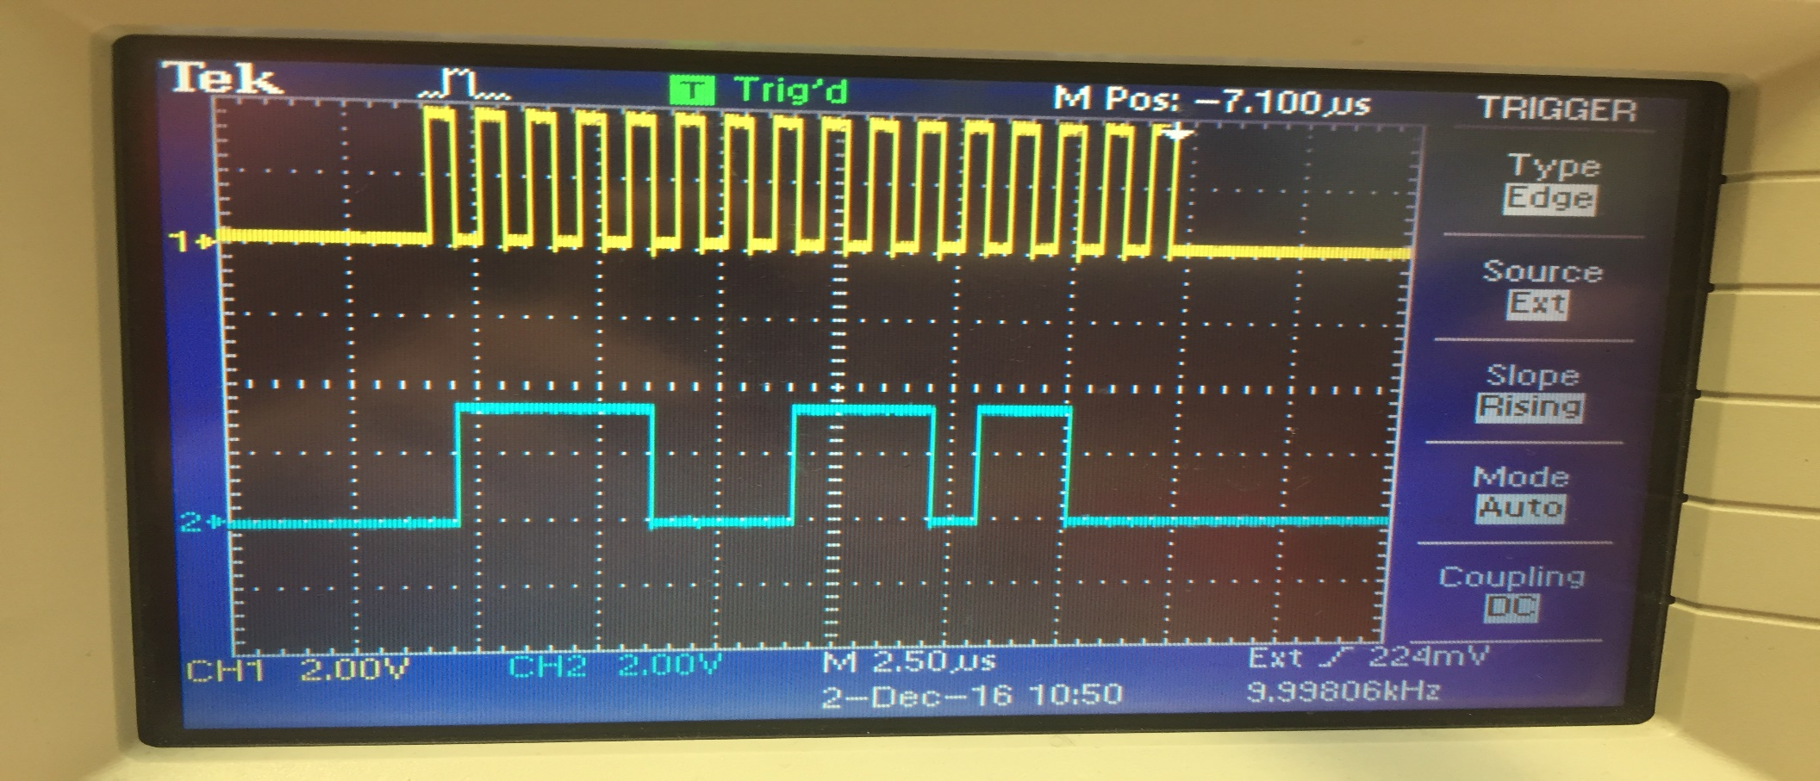

Above are the modelsim and oscilloscope outputs for an input of 10’h23b which both agree with each other. DAC_SCK is measured at TP3 and DAC_SDI is measured at TP1, where the scope had to be triggered using external signal DAC_CS at TP2.

Experiment 11

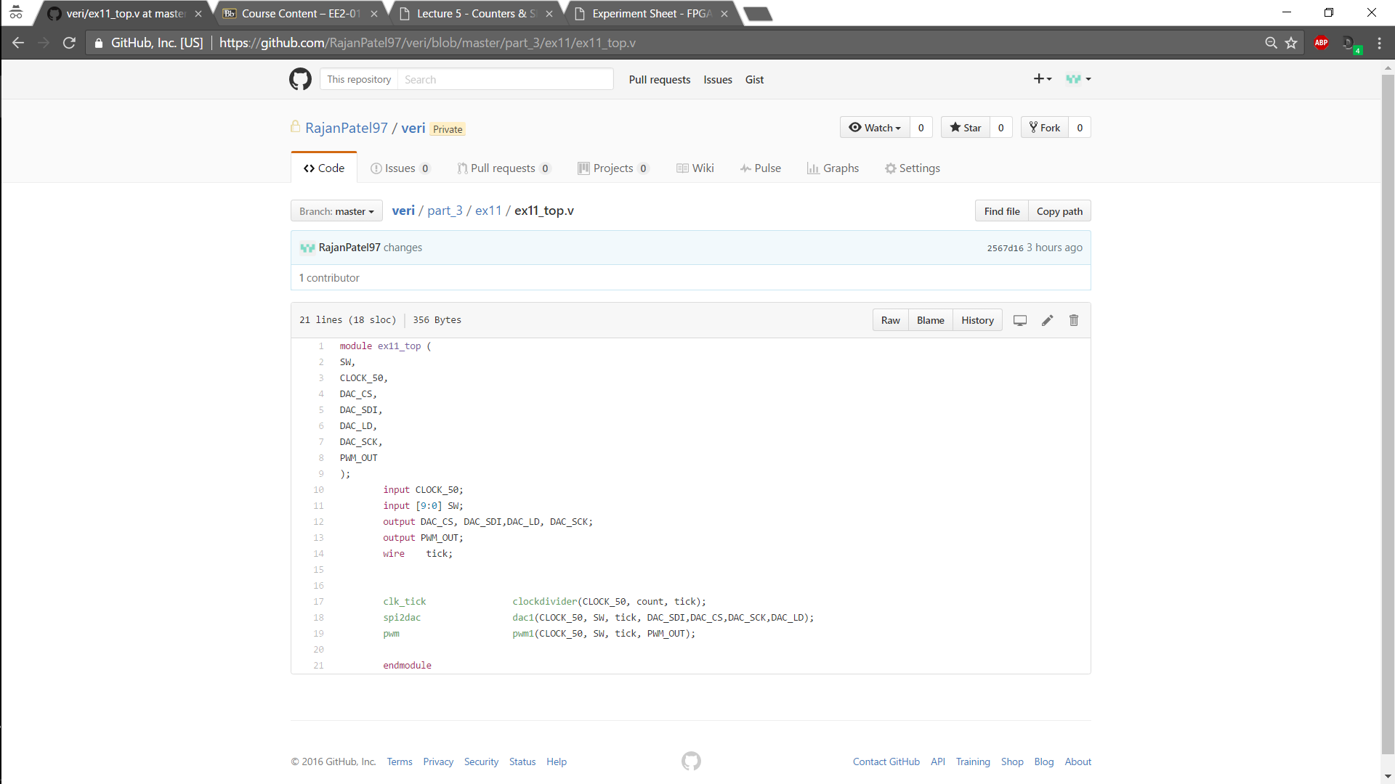

In this experiment the output voltage range for the PWM was the same as for the DAC, but PWM wasn’t as clear which I presume is due to the output resolution of the PWM in terms of its quantisation, however they did show proportionality to one another as expected. Again both have the same clock and load clock as well as same data coming in from the switches. The DAC and PWM outputs had to be found from the qsf file as they differ from the names on the board in contrast with that on the FPGA, so wiring the top module requires more care in this case. Above is the top module.

Experiment 12

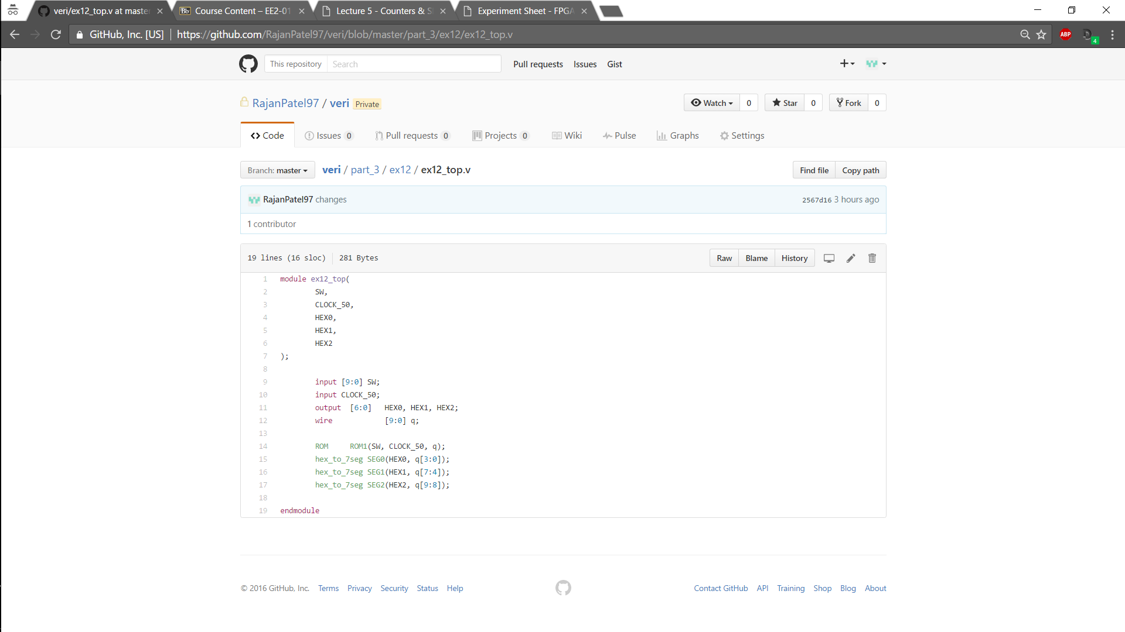This experiment uses a 1K X 10bit ROM that stores a table of sine values which is addressed using switches and the data is outputted to the three SEG displays. when testing the output on the screens had the same values as in the script .mif file, so the code was verified. The rom checks the address every positive clock cycle.

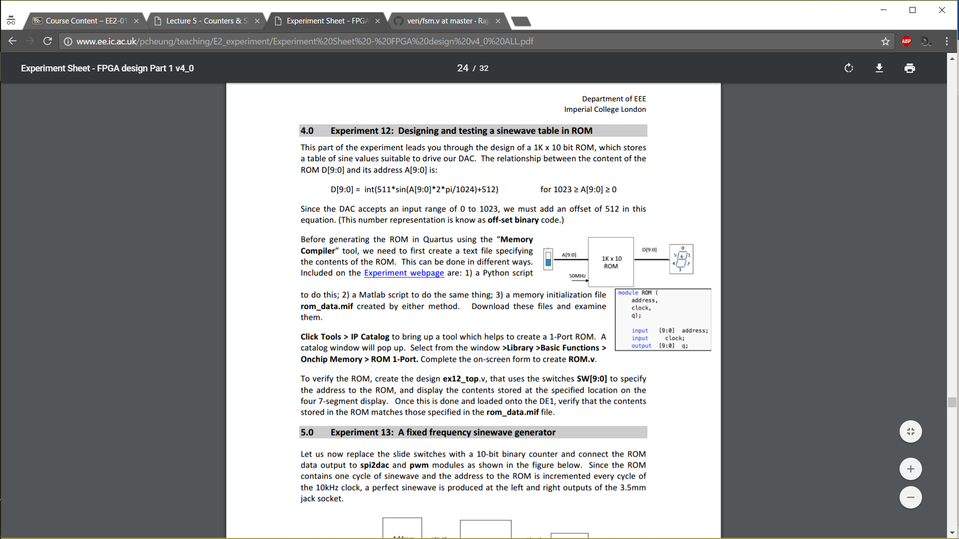The output equation is:

Below is the RTL top – level design which gives a clean overview of how the code is implemented.

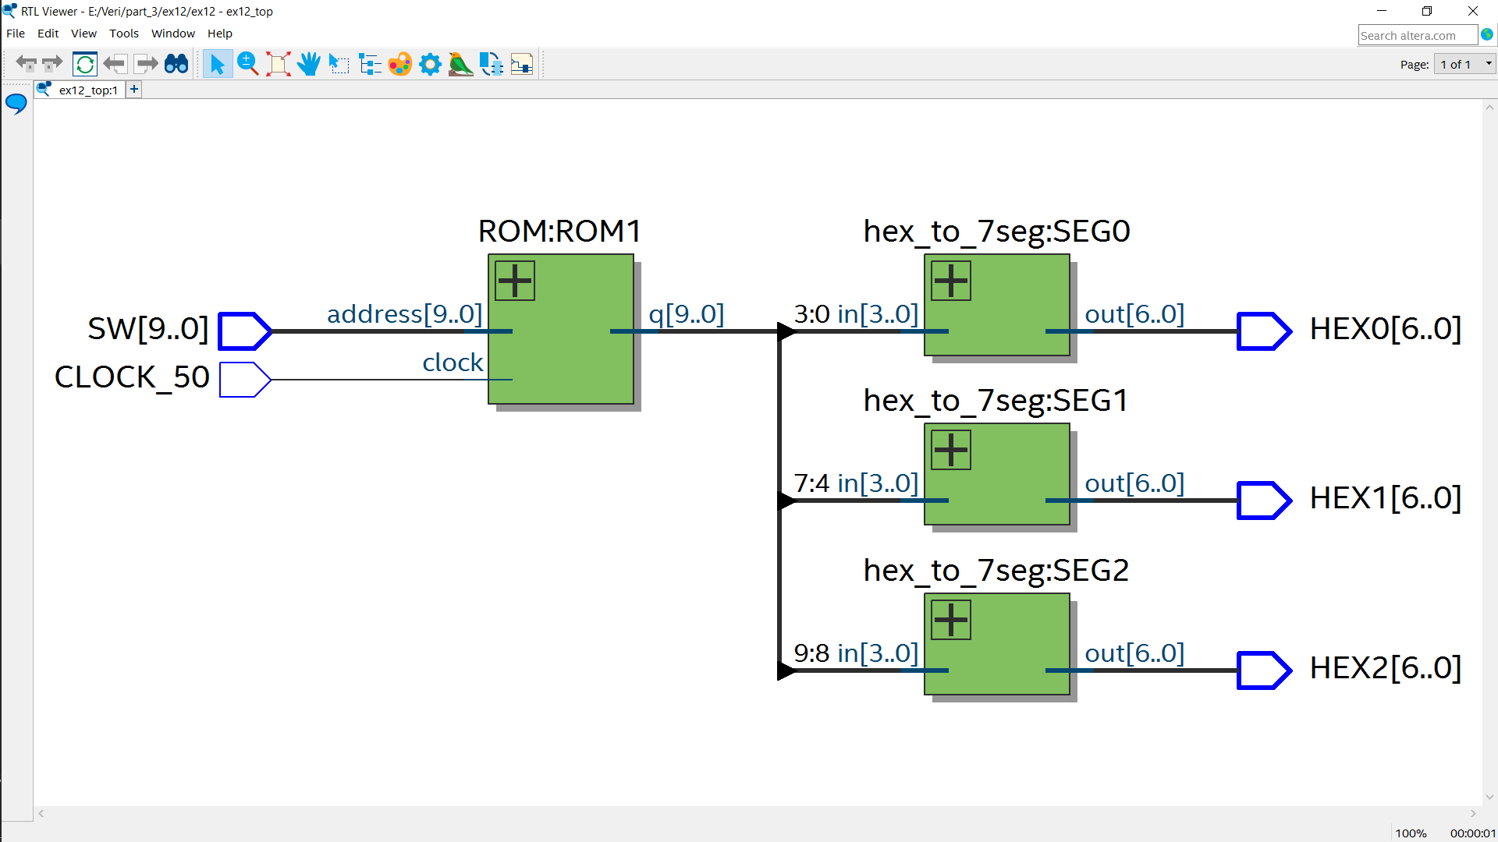

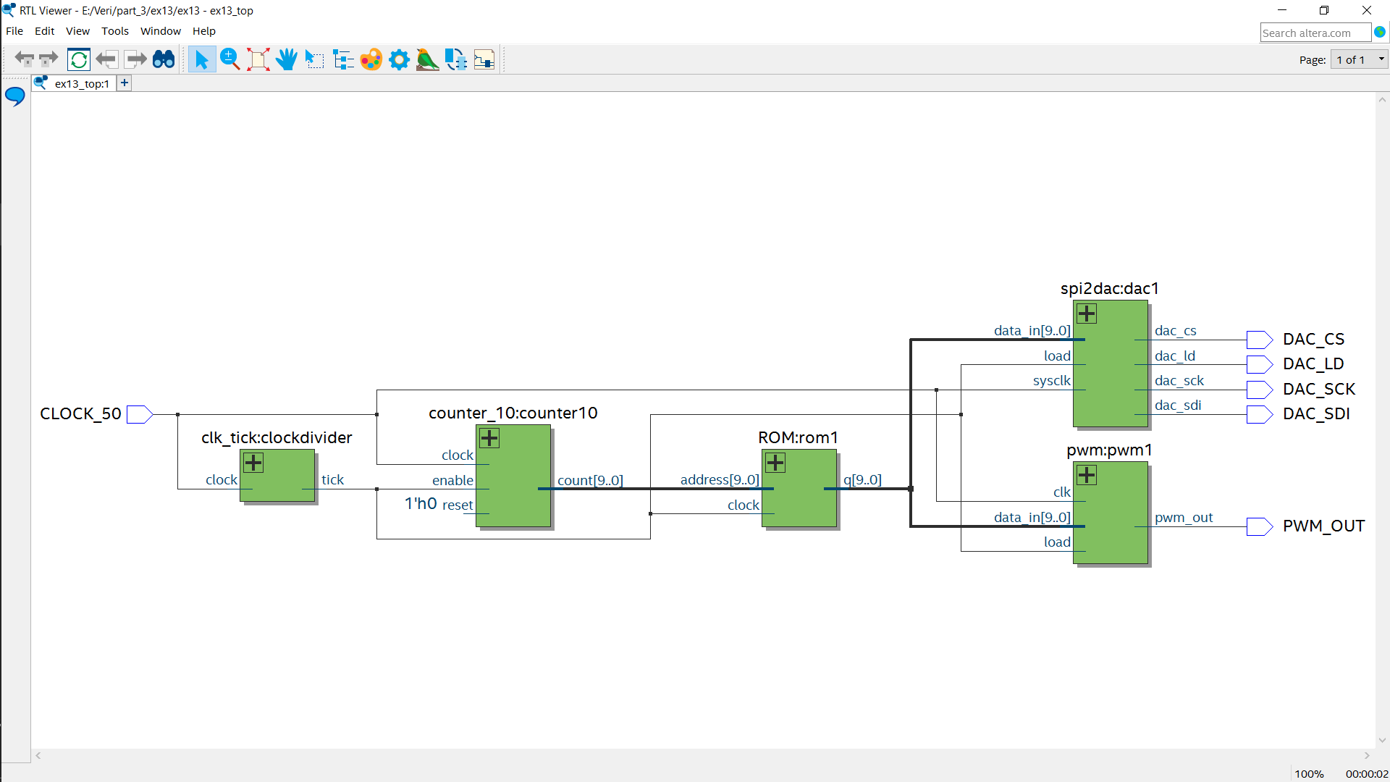Experiment 13

In this experiment I replaced the sliding switches with a 10-bit binary counter which is enabled every 10KHz. The ROM contains 1024 cycles of a sinewave and at every cycle of the 10Khz clock it is incremented by 1. Therefore 10000/1024 = 9.77Hz which is just below 10 and has been verified by the output of both the PWM and the DAC which both have frequency around 10Hz as shown below.

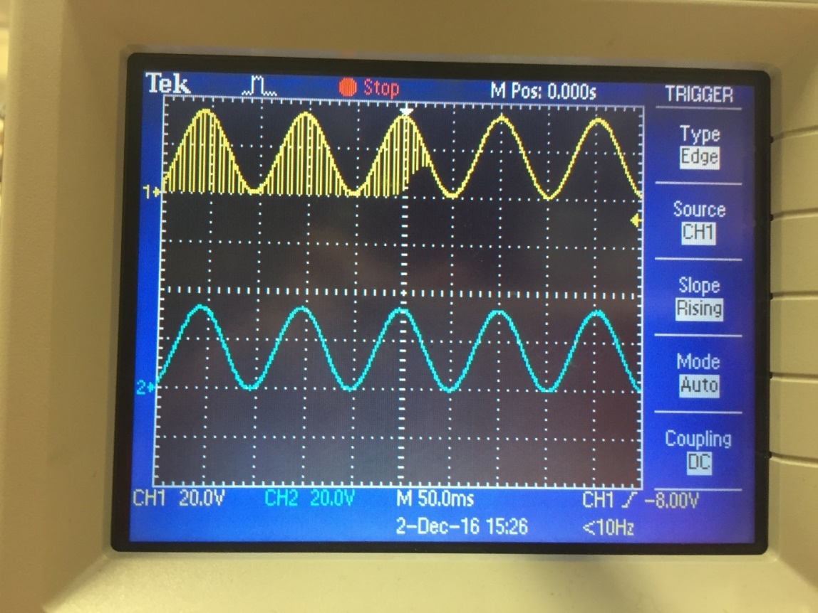

On the left, each interval is 50ms. Each cycle occurs every 2 intervals, so 1/100ms = 10Hz.

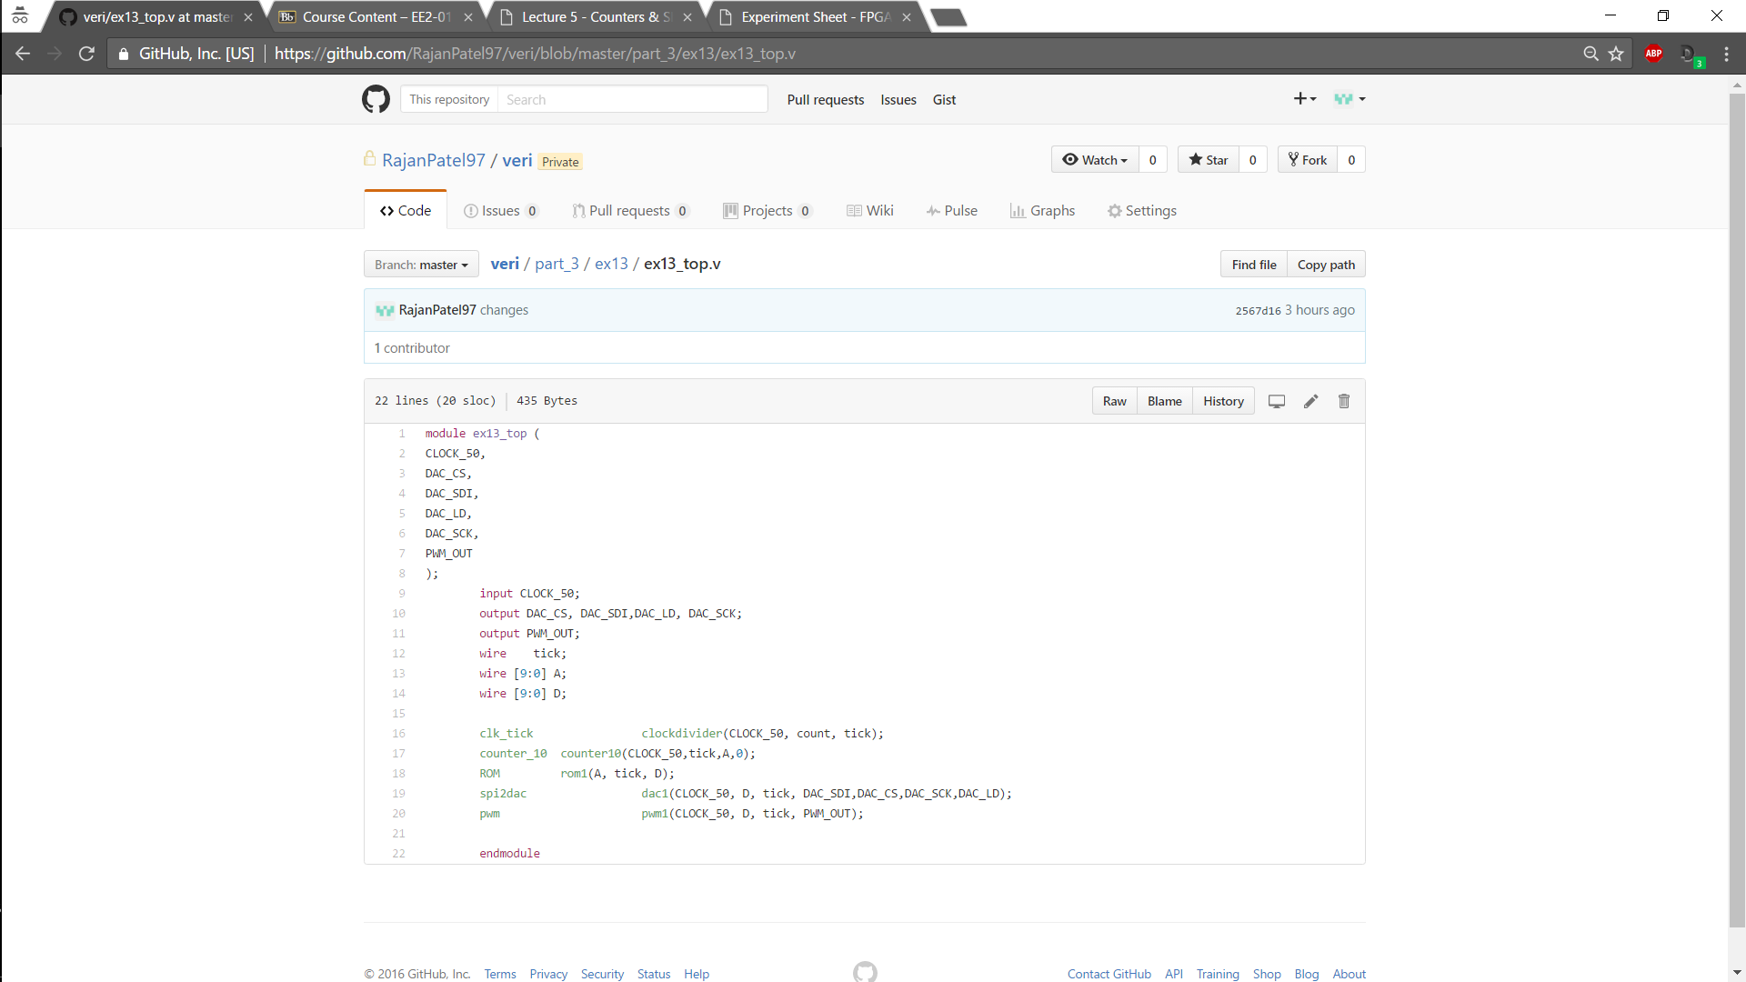On the left is the top level module with the 10-bit counter operating on the same basis as the 16-bit counter already seen in previous exercises.

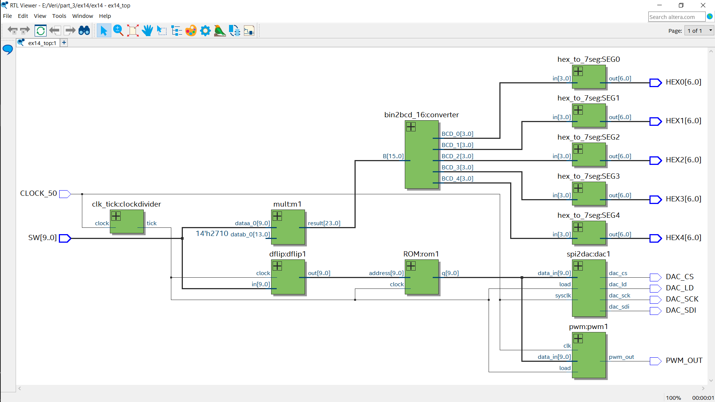Experiment 14 (Optional Challenge)

The above circuit combines all previous experiments in this part. The switches are used to advance the address i.e the phase every clock cycle to the ROM. The switch address value is multiplied by 10000 and the top 14 bits are outputted to the SEG displays to show the frequency of the sine wave.

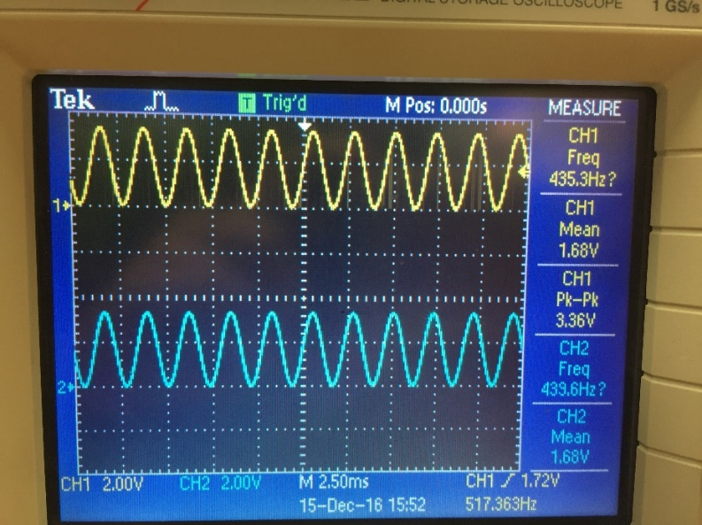This is indeed correct as when the switches are placed as below on the left the output to the SEGS and therefore the frequency should be 439Hz which is shown very close to the values measured on the left. Switch configuration for 439Hz is 10’b00000101101.

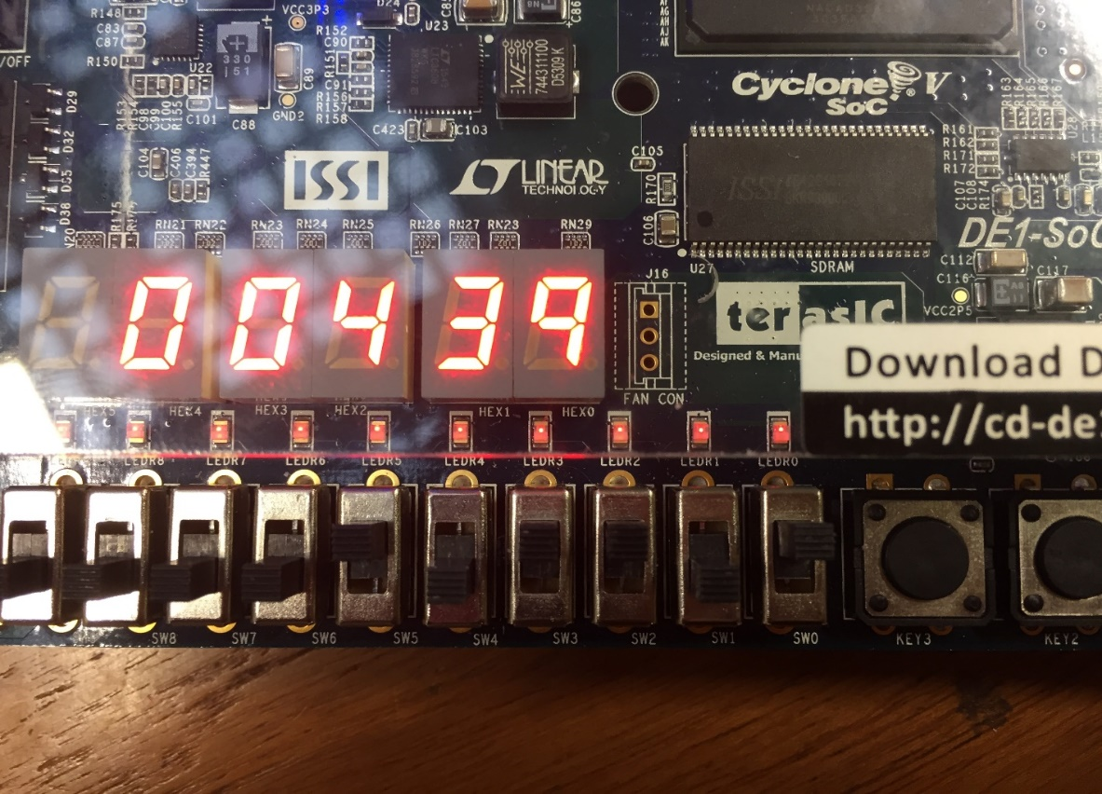

Experiment 15 (Optional)

This experiment was the same as the previous one but with the potentiometer controlling the frequency of the sine wave. The potentiometer was very sensitive and it was quite difficult to obtain the measurement below, however it was eventually obtained.

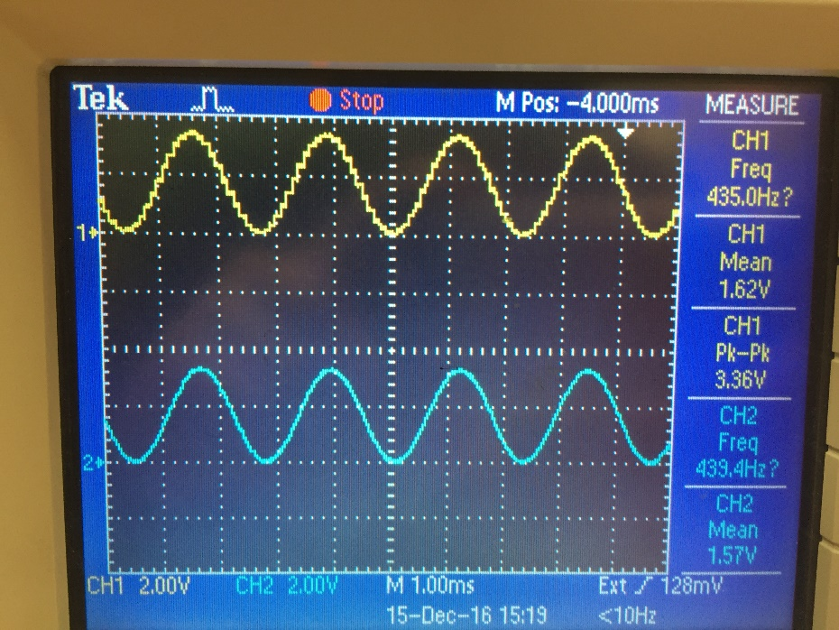

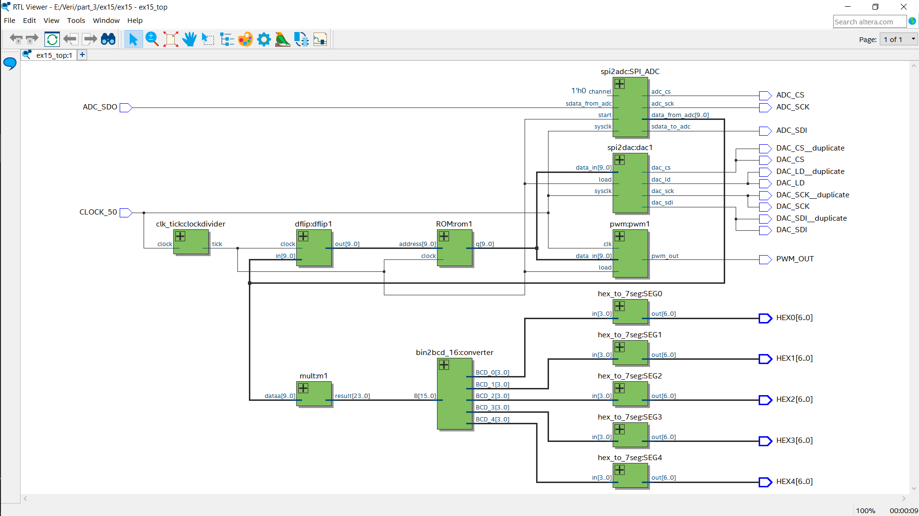Below is the block diagram and the top-level code. I had to choose channel 0 to select the potentiometer and change some wiring to include the inputs and outputs of the ADC, however it was very similar to the previous experiment, but this time using the ADC.

